Matching the local QRhomework System to the online system

1. Start XAMP and start both APACHE and MySQL and open the local version of PHPmyAdmin Select the current local database and select Operations and rename

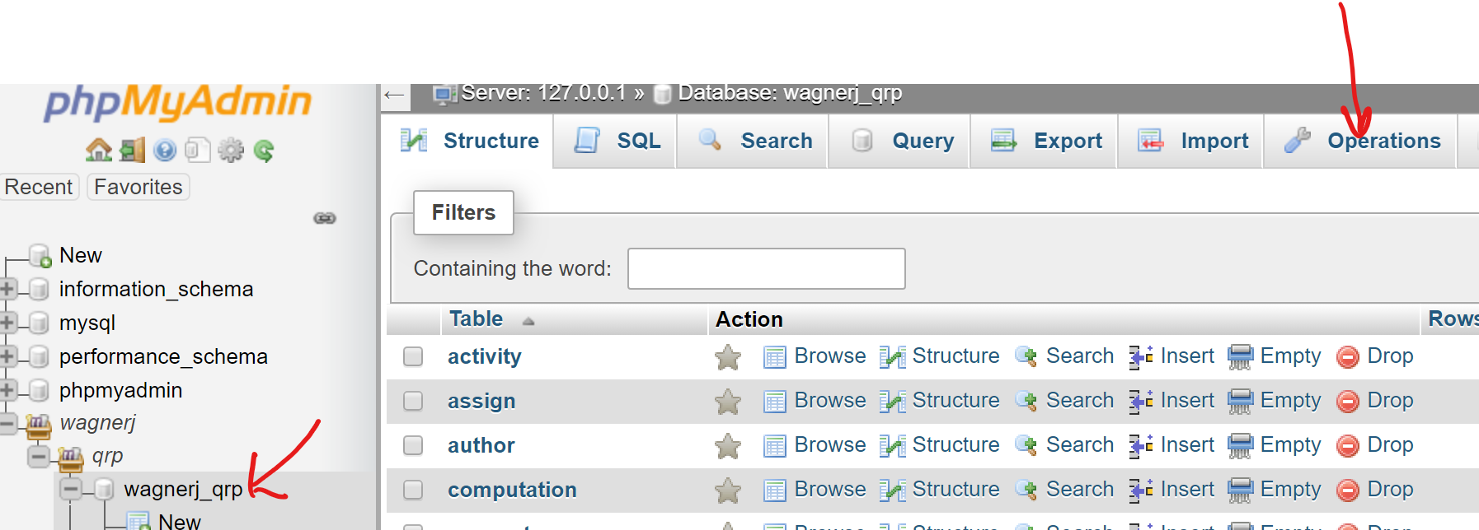

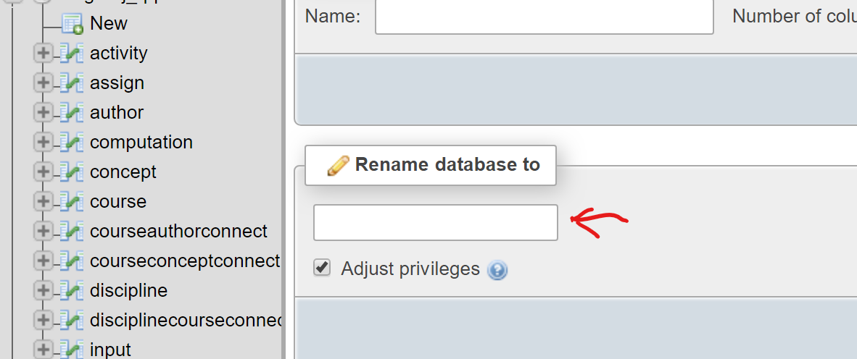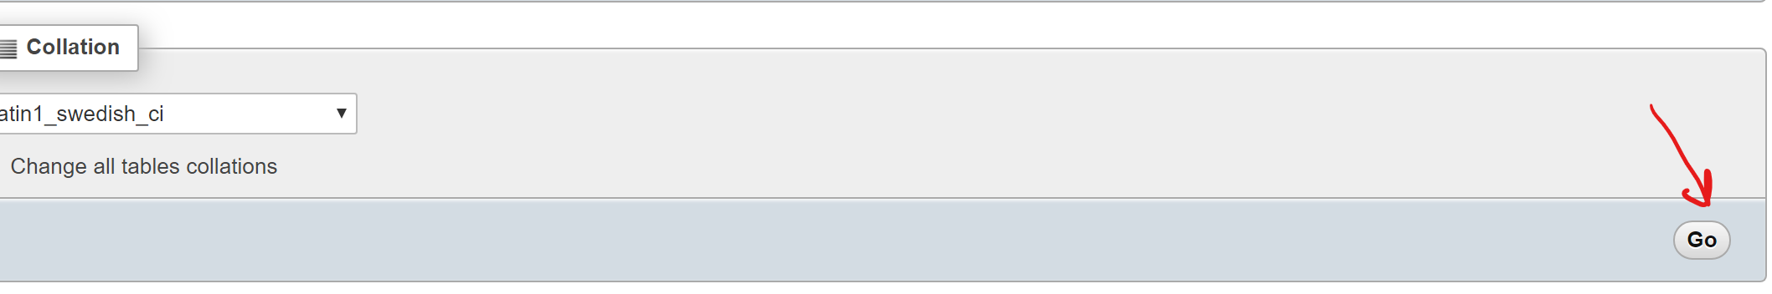

Give it a name so that if you have to recover it you can.

1. Log on to the Host Gator C panel and find the current database with PHPmyAdmin then Export

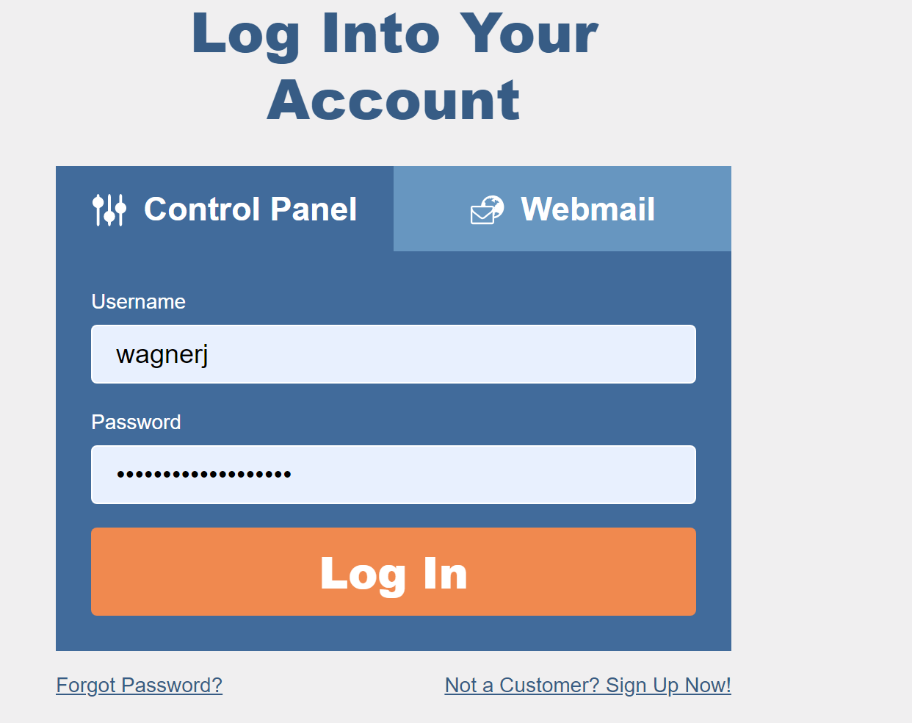 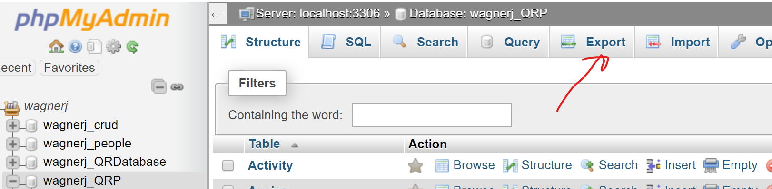

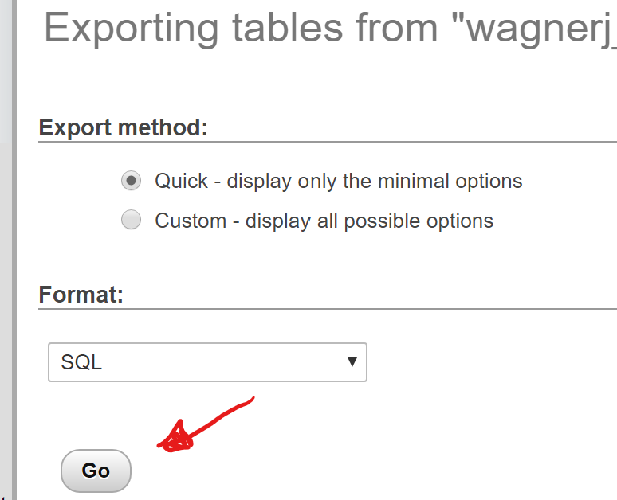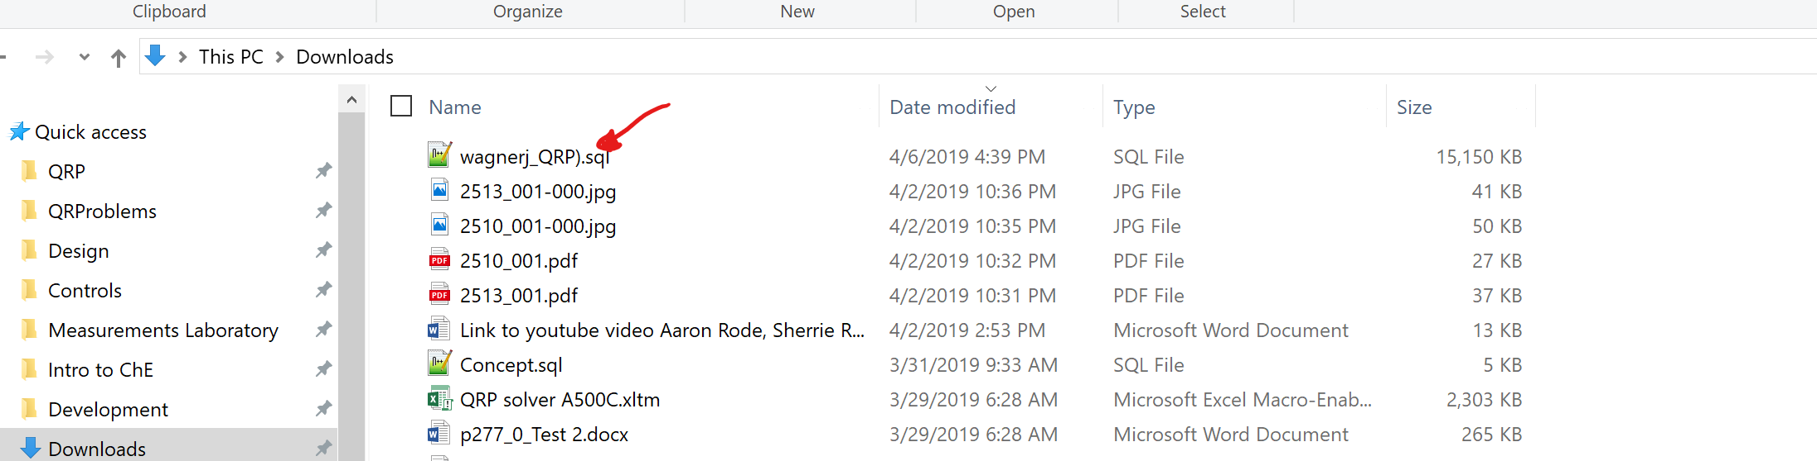This should put it in the Downloads directory

1. Go to the local PHPMyAdmin and Select the Server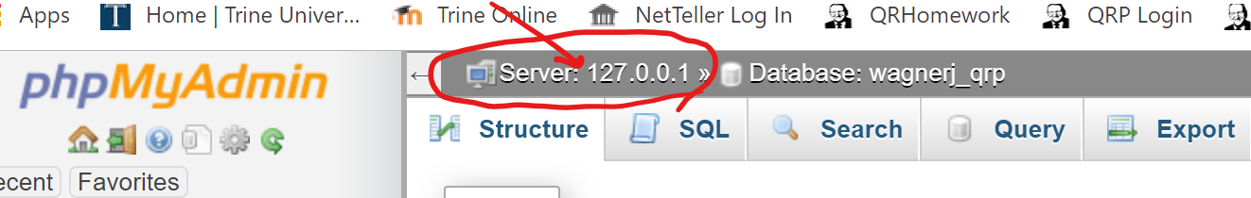

Then Select Databases Create Database and give it the name wagnerj_QRP and select create

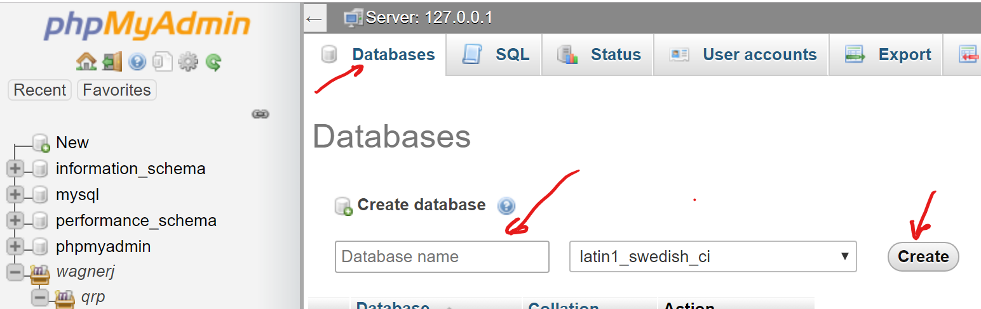

1. For the newly created database Import the downloaded file

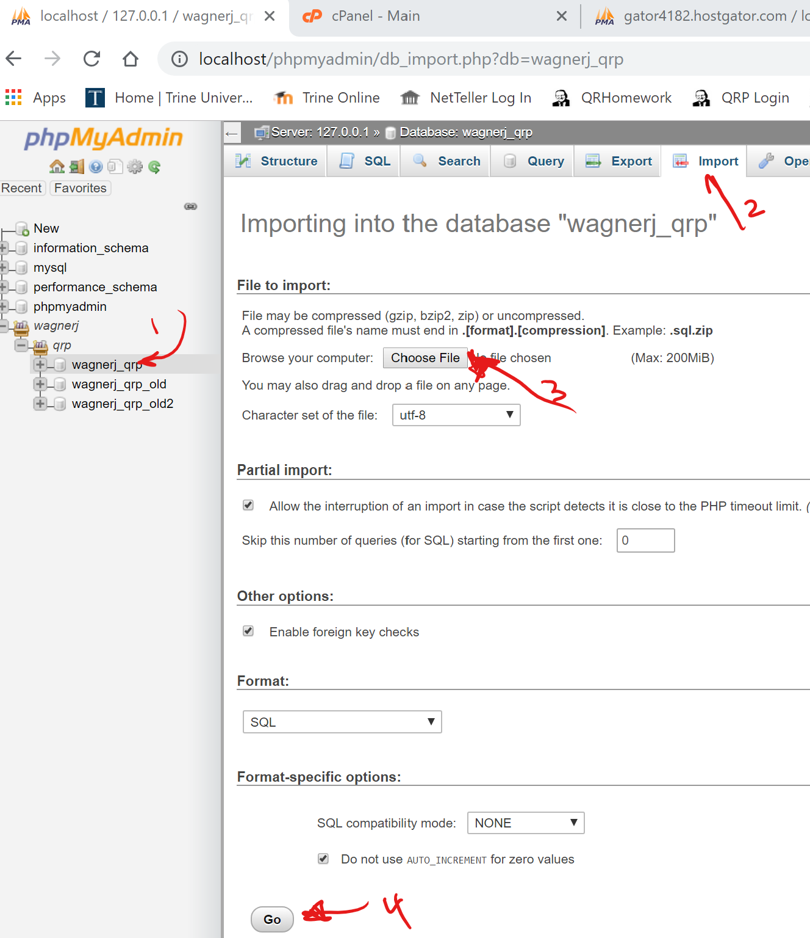 Downloading can take a while

1. Now update the file structure – Go to FileZilla Client pull down the connection from the QuickConnect

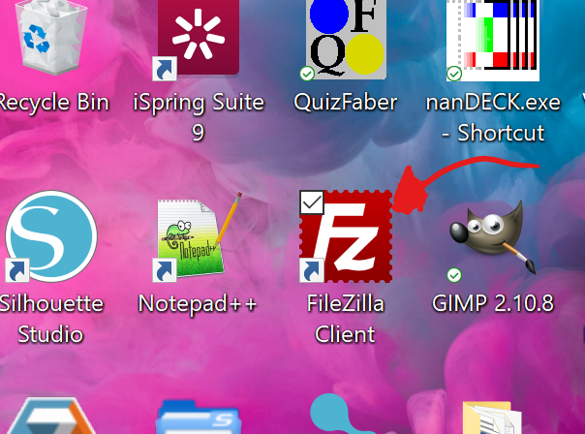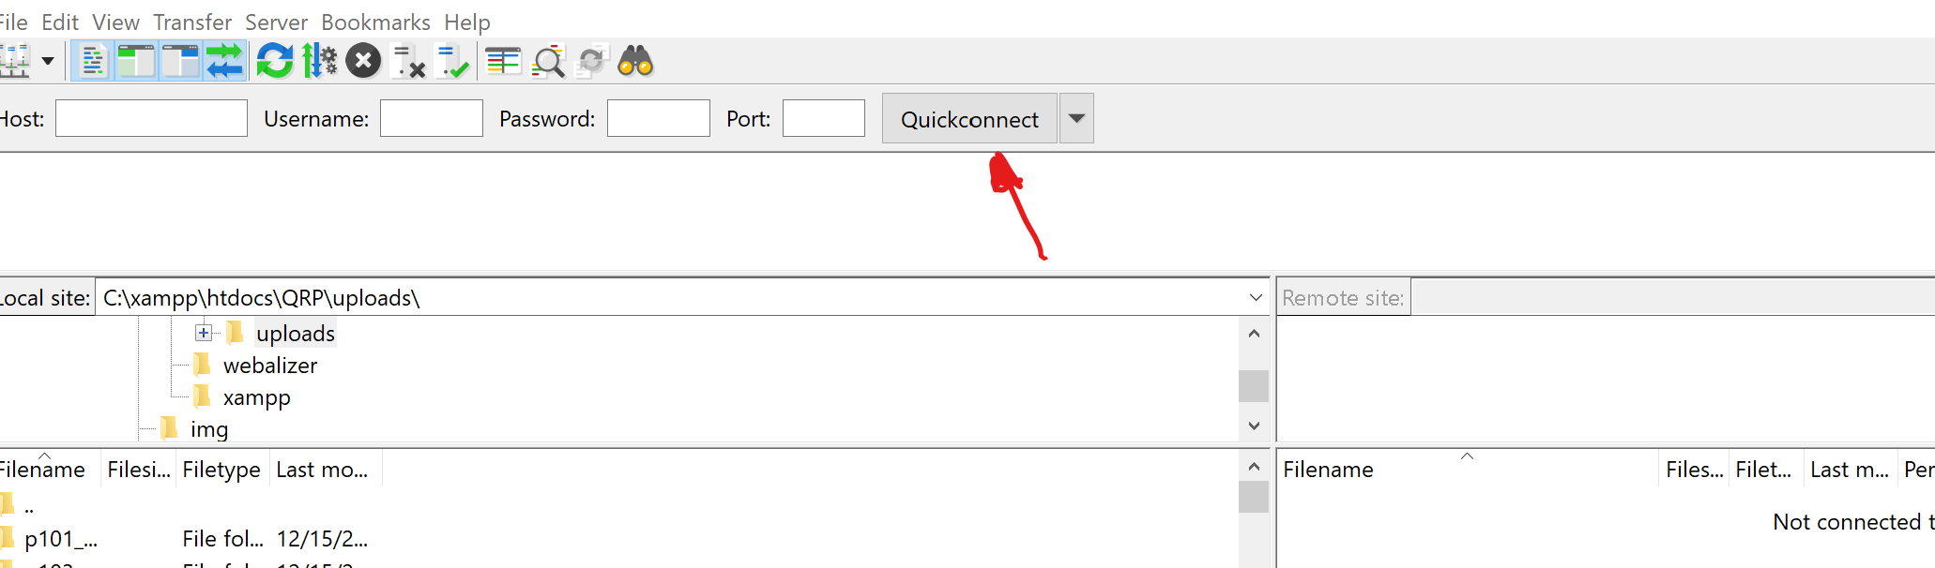

1. 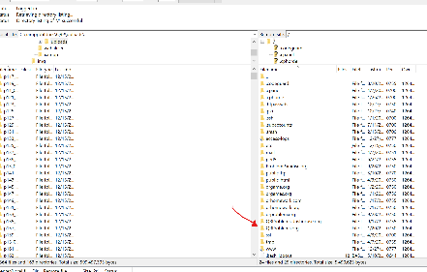 Select the directory where the files are located – Find the uploads directory

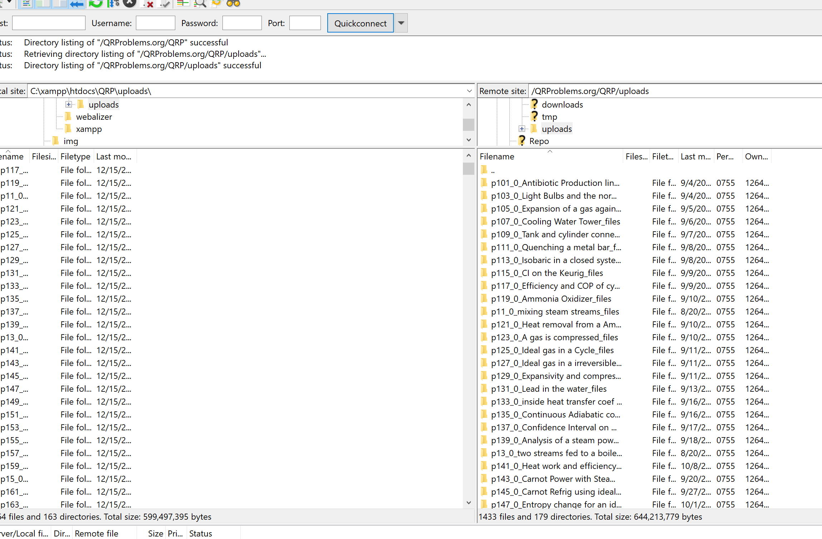

1. Highlight the files on the server that you want to download then right click and download

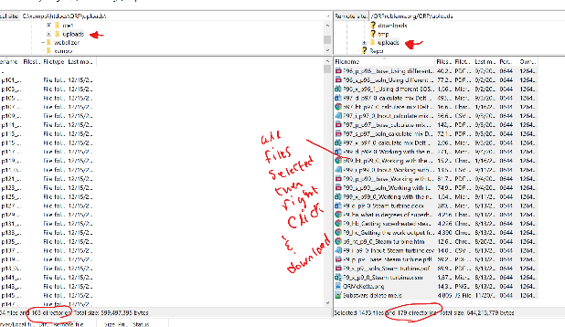

1. For duplicate files it will come up with a prompt – Select Update if source is newer and do this for all download files. After a bit (less than a minute for me) it returned that it was finished.